**Unicom TIC Management System**

## Key Features by Module

### User Account Management

* Admin:
* Must first create user accounts (username, password, role) before adding Student, Staff, or Lecturer information.
* Can view, update, and delete all user accounts.

### Course & Subject Management

* Admin: Can add, update, delete, and view courses and subjects.
* Staff, Students, Lecturers: No access to manage or view this section.

### Student Management

* Admin: Can add, update, and delete student records.
* Student details are added after their user account is created.
* Students: Can view their own details only.

### Staff Management

* Admin: Can add, update, and delete staff records.
* Staff details include name and role.
* Staff user account must be created first.

### Lecturer Management

* Admin: Can add, update, delete, and view lecturer records.
* Lecturers are assigned to courses.
* Lecturer user account must be created first.

### Admin Management

* Admin: Can add other admin users using a dedicated form.

### Exam & Marks Management

* Admin / Staff / Lecturers: Can add and update exams and student marks.
* Students: Can view their own marks.

### Timetable Management

* Admin: Can add, update, and delete timetable entries (subject, time, room).
* Staff: Can add and update timetable entries (no delete).
* Lecturers / Students: Can view timetables (including labs/halls).

### Room Management

* Admin: Can add, update, and delete rooms (labs and lecture halls).

### Feedback System

* Students: Can submit anonymous feedback.
* Admin / Staff / Lecturers: Can view feedback

### Study Materials Management

* Admin / Staff / Lecturers: Can add, update, and delete study materials.
* Students: Can only view

## Technologies Used

* Visual Studio – for development and designing forms
* C# – main programming language used
* WinForms – used to build the graphical user interface
* SQLite – database engine to store all application data
* System.Data.SQLite (NuGet package) – integration between SQLite and C#
* Manual MVC Pattern – separation of UI, business logic, and data layers

## Challenges Faced and Solutions

* **Challenge**- Handling many-to-many table updating caused issues with duplicate data.
* **Solution**-Solved by adding conditional checks to prevent duplicate entries during updates.

**Note: Default admin login: Username – admin, Password – admin123**

# 1.Login

Figure 1 Login Form UI

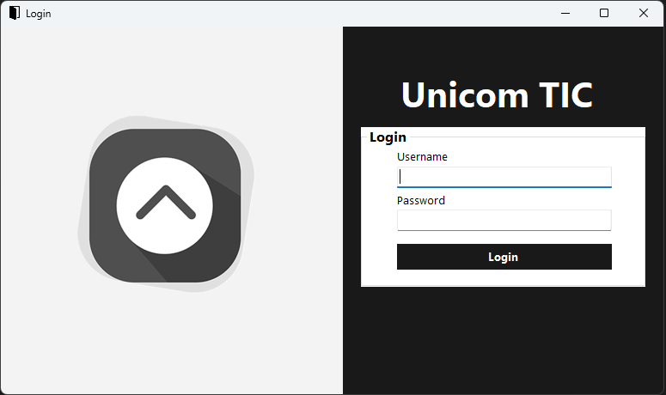

Figure 2 Login Form Code

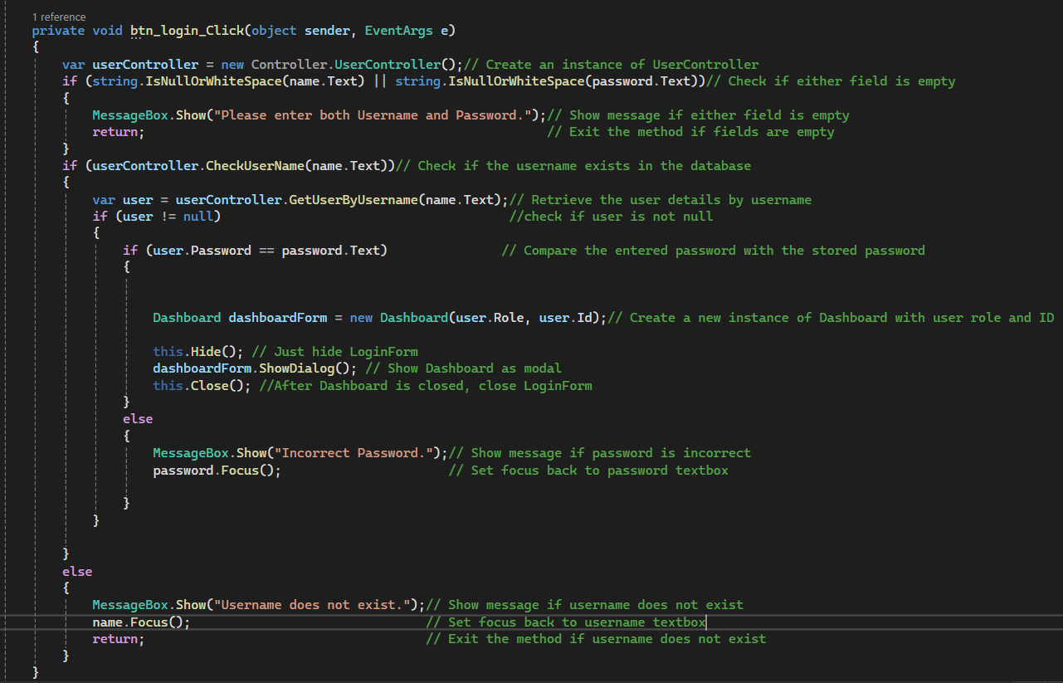

Figure 3 CheckUserName Method in User Controller

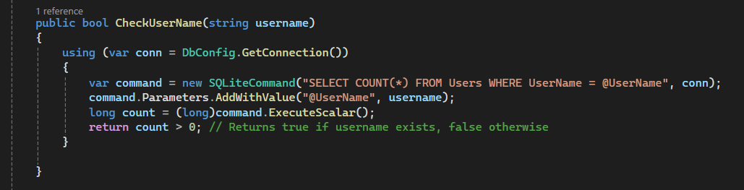

Figure 4 GetuserByUserName method in User Controller

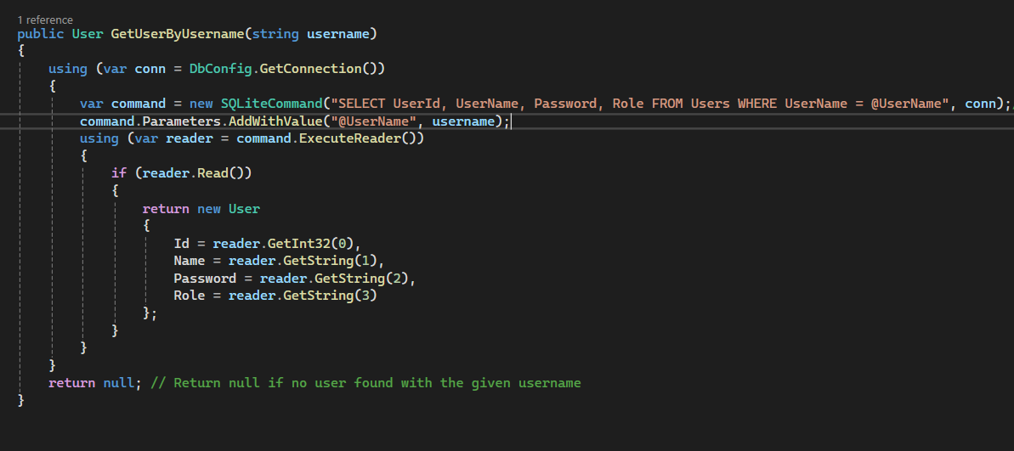

# 2. Assigning Lecturers to Courses

Figure 5 Lecturer's Courses Form UI

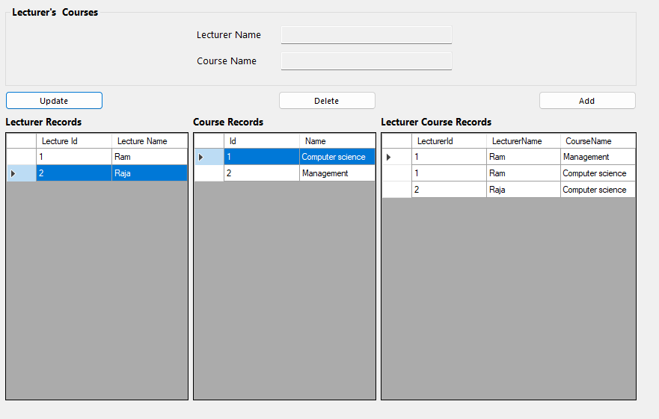

## Lecturer's Courses Form Code

Figure 6 Selecting Lecturer from Lecturer Records

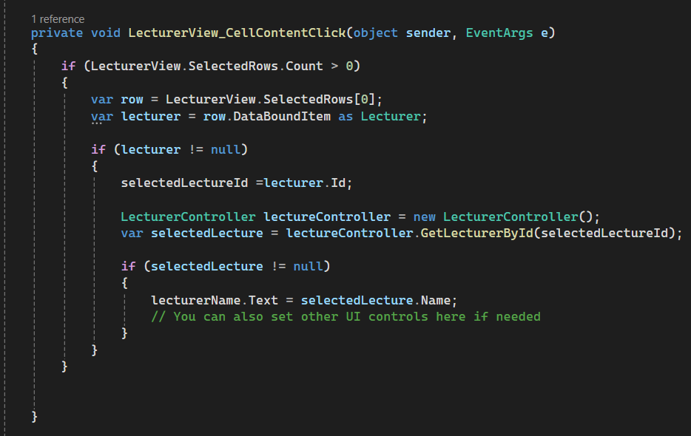

Figure 7 Selecting Course from Course Records

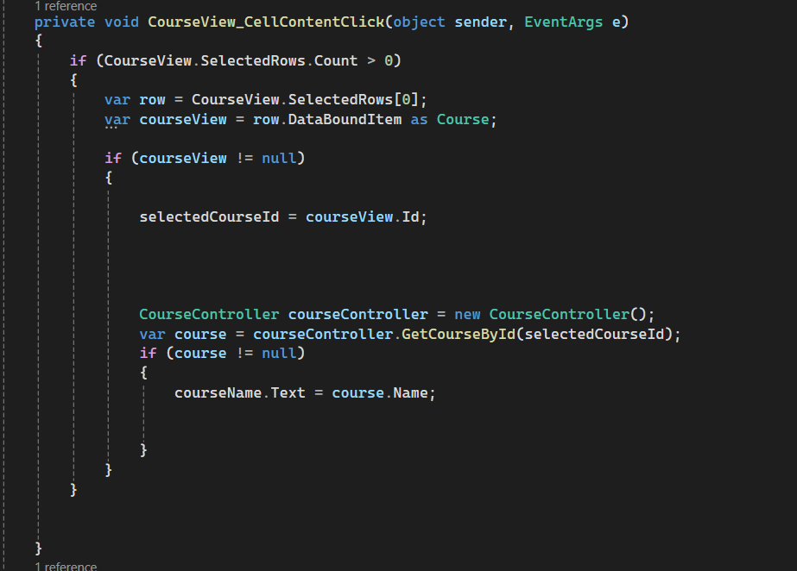

Figure 8 Lecturer's Courses Form Code for Add button

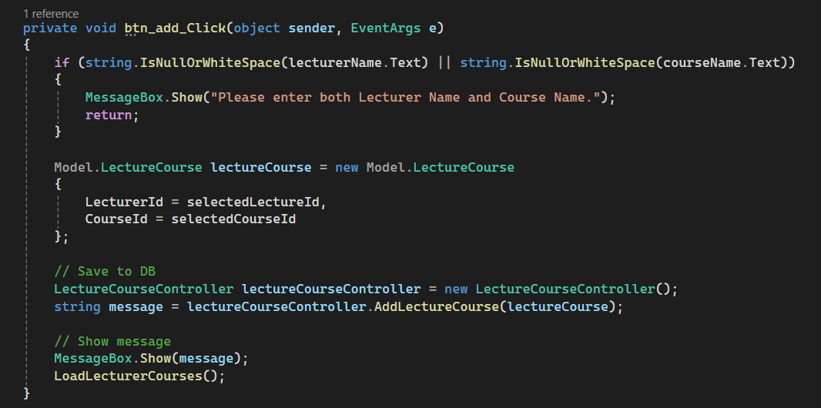

## LecturerCourse Controller Code

Figure 9 Add Lecturer’s Course

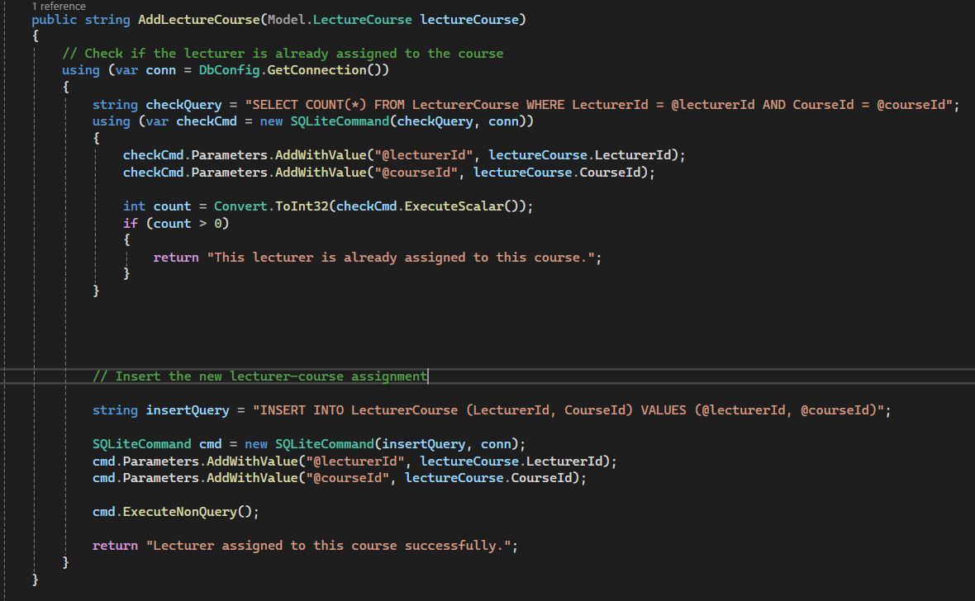

# 3. Update Lecturer’s Course

## Lecturer's Courses Form Code

Figure 10 Selecting Lecturer-Course Pair from Lecturer Course Records

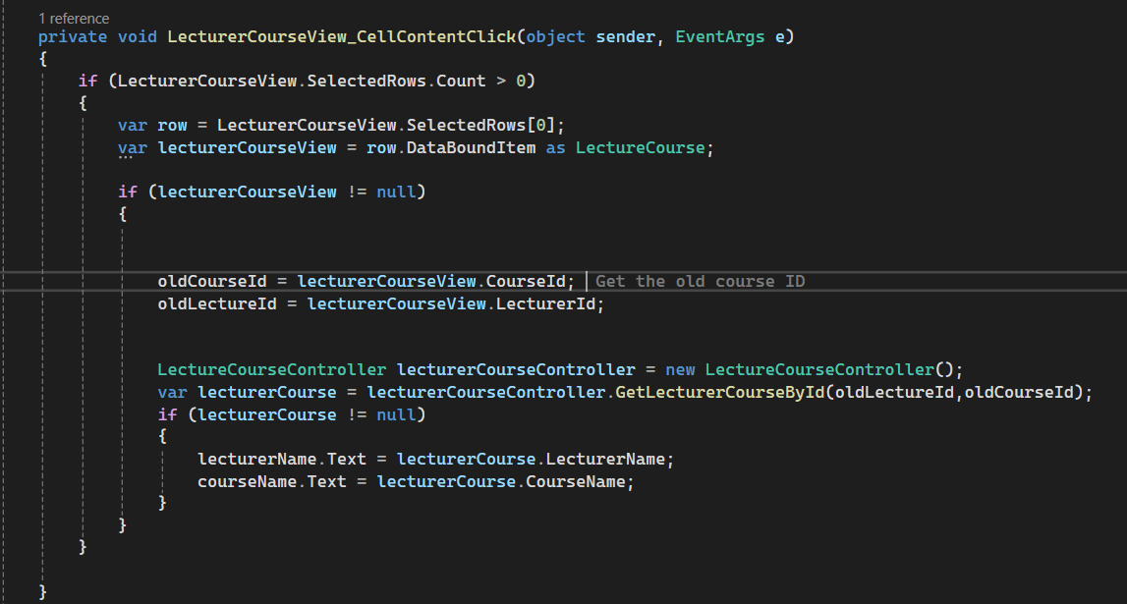

Figure 11 Select Lecturer from Records (If Changes Are Needed)

Figure 12 Select Course from Records (If Changes Are Needed)



Figure 13 Code for Update Button

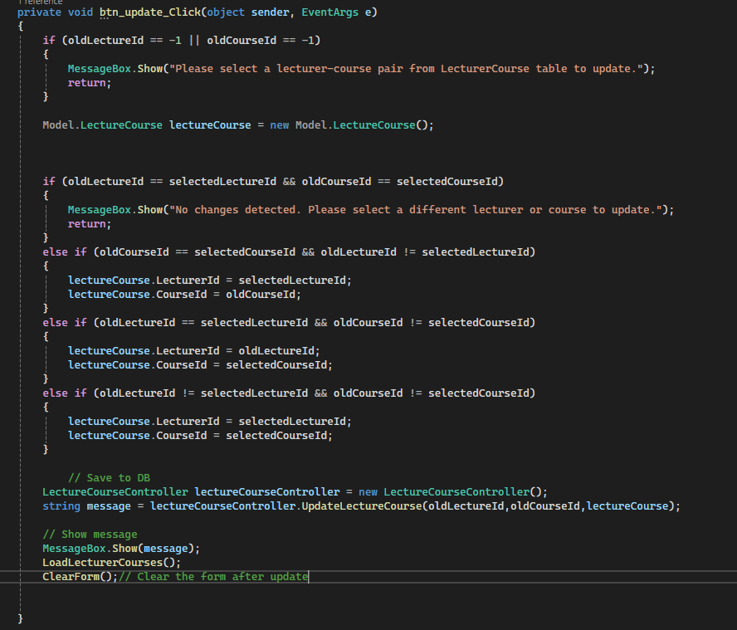

## LecturerCourse Controller Code

Figure 14 Update Lecturer's Course

